In the first set of code provided, when given a string, it seems the code only picks up lowercase letters that are at the start of the sentence as indicated by the screenshot of results I tested with below:

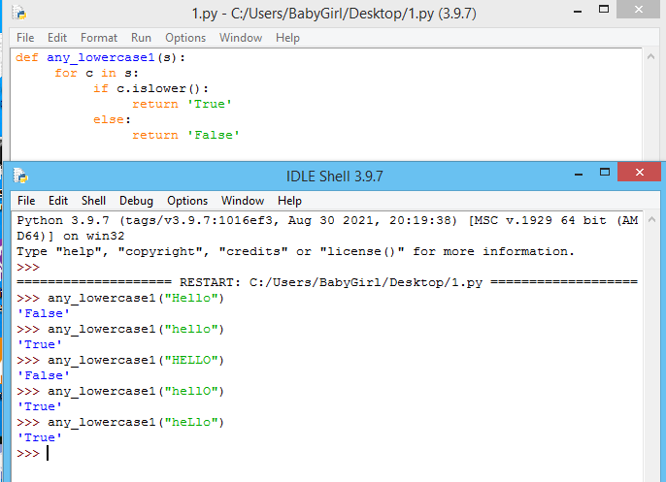

In the second set of code provided, when given a string, it seems the code picks up all input as lowercase letters as indicated by the screenshot of results I tested with below:

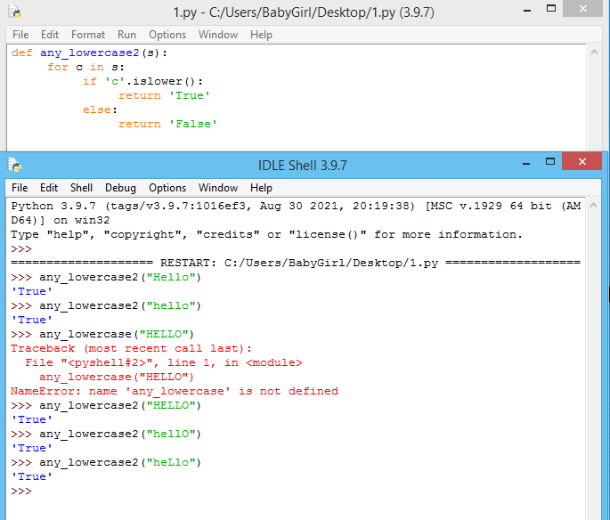

In the third set of code provided, when given a string, it seems the code only picks up lowercase letters that are at the end of the sentence as indicated by the screenshot of results I tested with below:

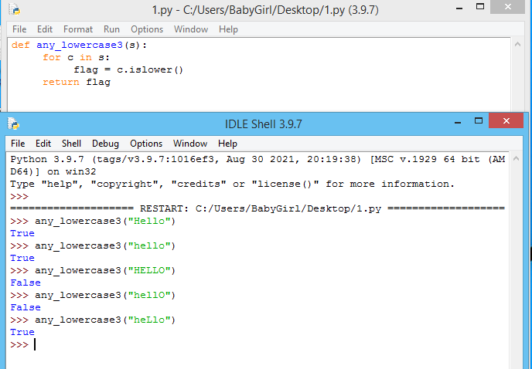

In the fourth set of code provided, when given a string, it seems the code picks up lowercase letters correctly as it should as indicated by the screenshot of results I tested with below:

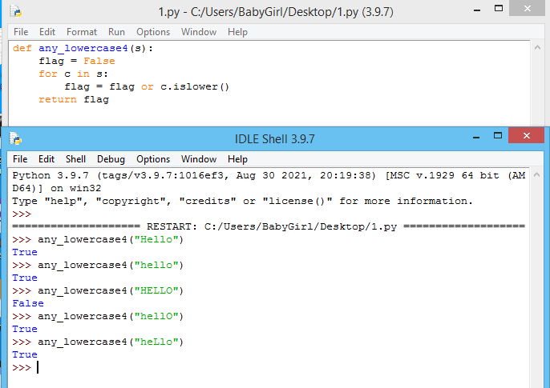

In the fifth set of code provided, when given a string, it seems the code picks up only sentences that are all lowercase letters and rejects any string that contains a single or more capital letter, kind of the opposite of what it is supposed to do, as indicated by the screenshot of results I tested with below:

